User Interface

Project name: Media Tracking Platform to Tackle Online Piracy

User Analysis:

MeRit: A Distributed Ledger System maintaining and monitoring the information on the copyrighted content provided by the legal owners. Such copyrighted content that could be accessed by the crawler to identify same or similar content on unauthorized websites. The crawler will index the URL and IP address of the platform hosting the content illegally. The system notifies the concerned owner of the copyright infringment, who verifies whether the content belongs to them.

How this works:

MeRiT combines web crawlers, deep web crawlers, distributed ledger technology and machine learning to address the issue on media piracy. The crawler searches for similar content or link to the content whose information has been stored on blockchain. The crawler indexes the information on the system. This is sent to the copyright content owner who then sends it to the content owner who can take it to the agency responsible for taking down the copyrighted content.

Documentation:

The main page (home page) has a search option. This search is free for users not logged in. You can create an account which gives you more privileges . We can also see a login/signup page when you can login and if you have an account or can create one. Below the search option, we can see surface web crawl, dark web crawl and social media crawl.

Next the Pricing tab displays the different packages where you can upgrade your account to a premium account namely silver, gold or platinum. Silver upgrade is a social media crawler, Gold upgrade is a Dark Web crawler and Platinum upgrade is a Live Crawler.

These three premium upgrades targets different users based on their interests. This could range from a single user trying to build his/her social media page without his/her content being stolen to a media company that could incur huge loss due to plagiarism.

Next to the pricing tab, there is a My Profile tab where the user can create their profile and add a brief description about themselves.

Coming down to the search, there are separate tabs where you can search for images, videos and articles separately. This is useful for segregation and easier navigation.

Website Layout:

1.User Profile Page

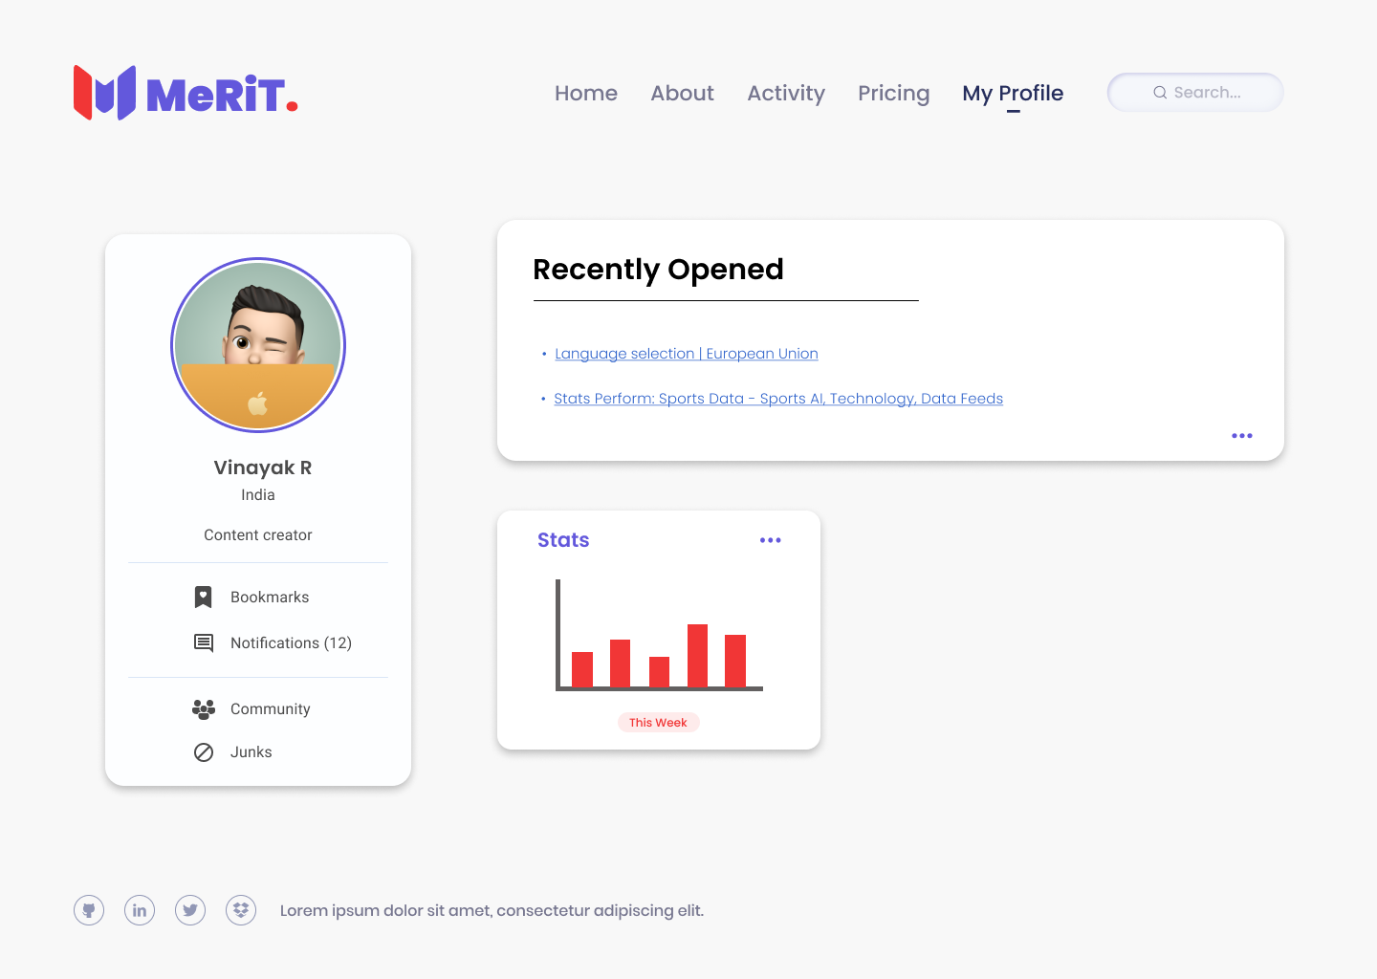

2.Search Result Page

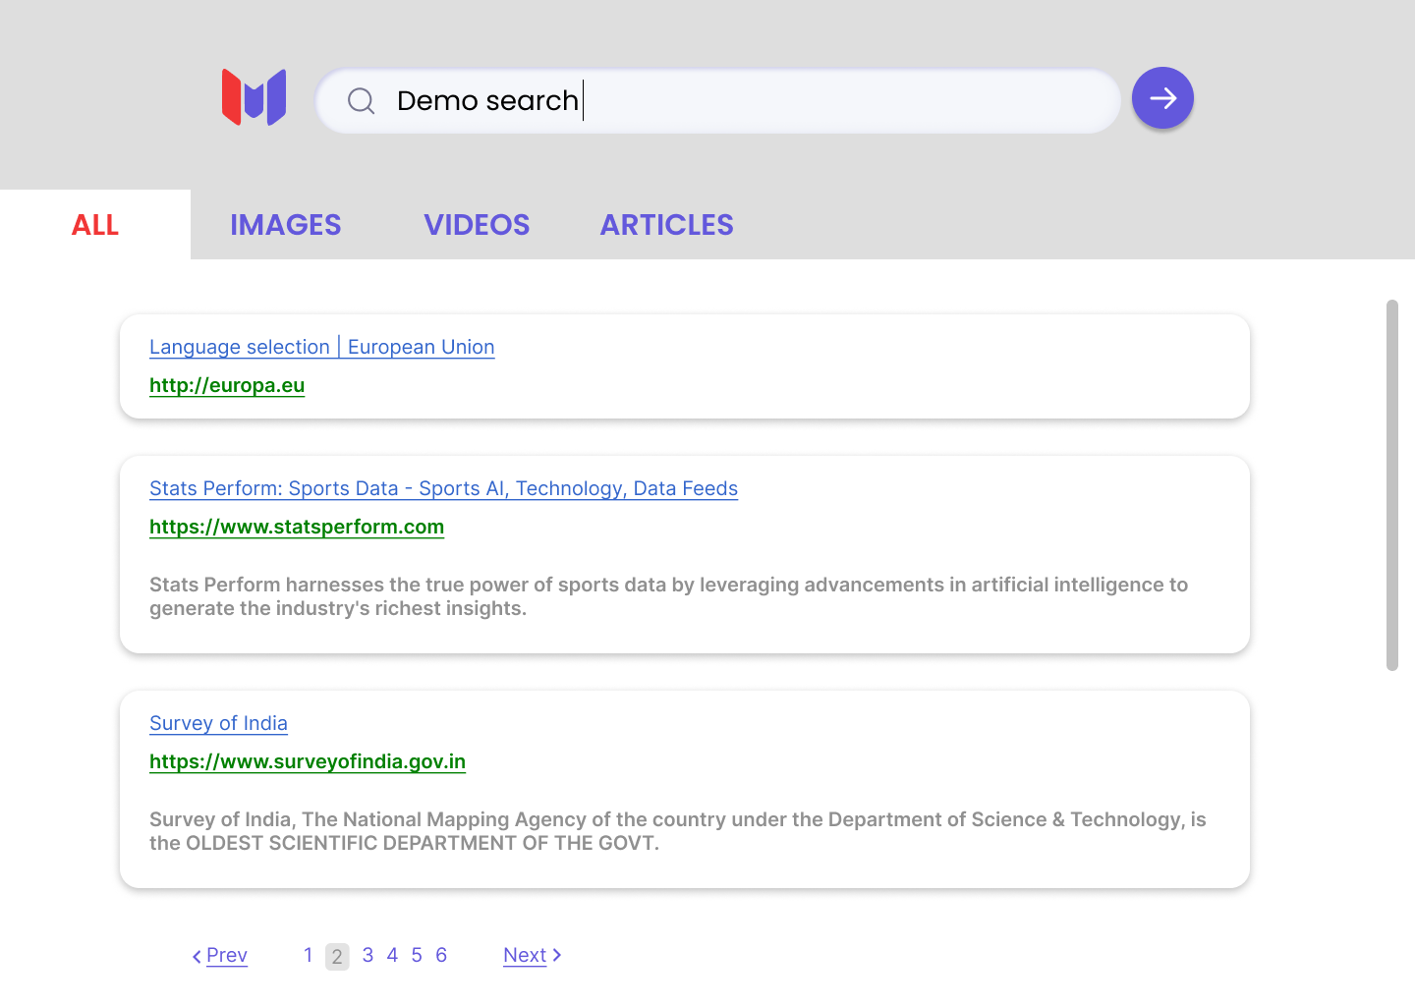

3.Demo Search Page

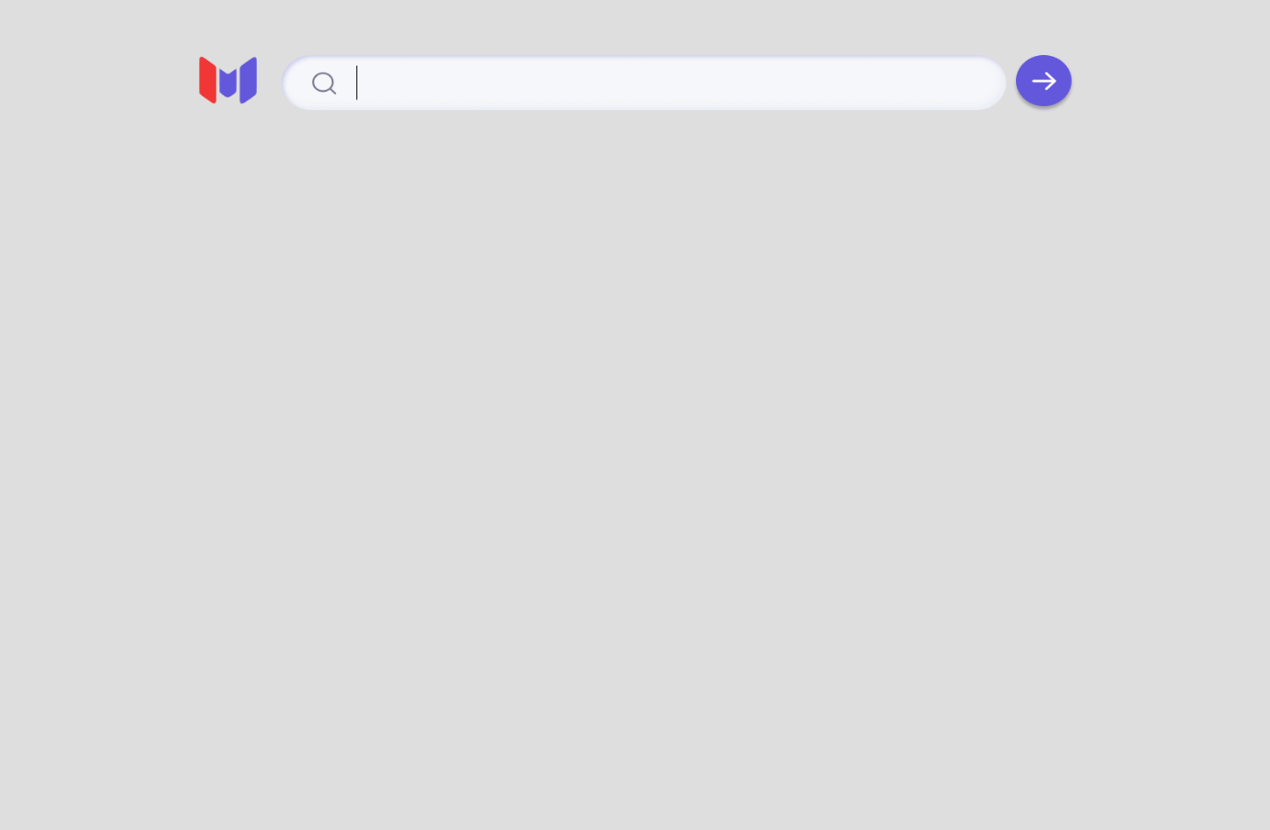

4.Home Page

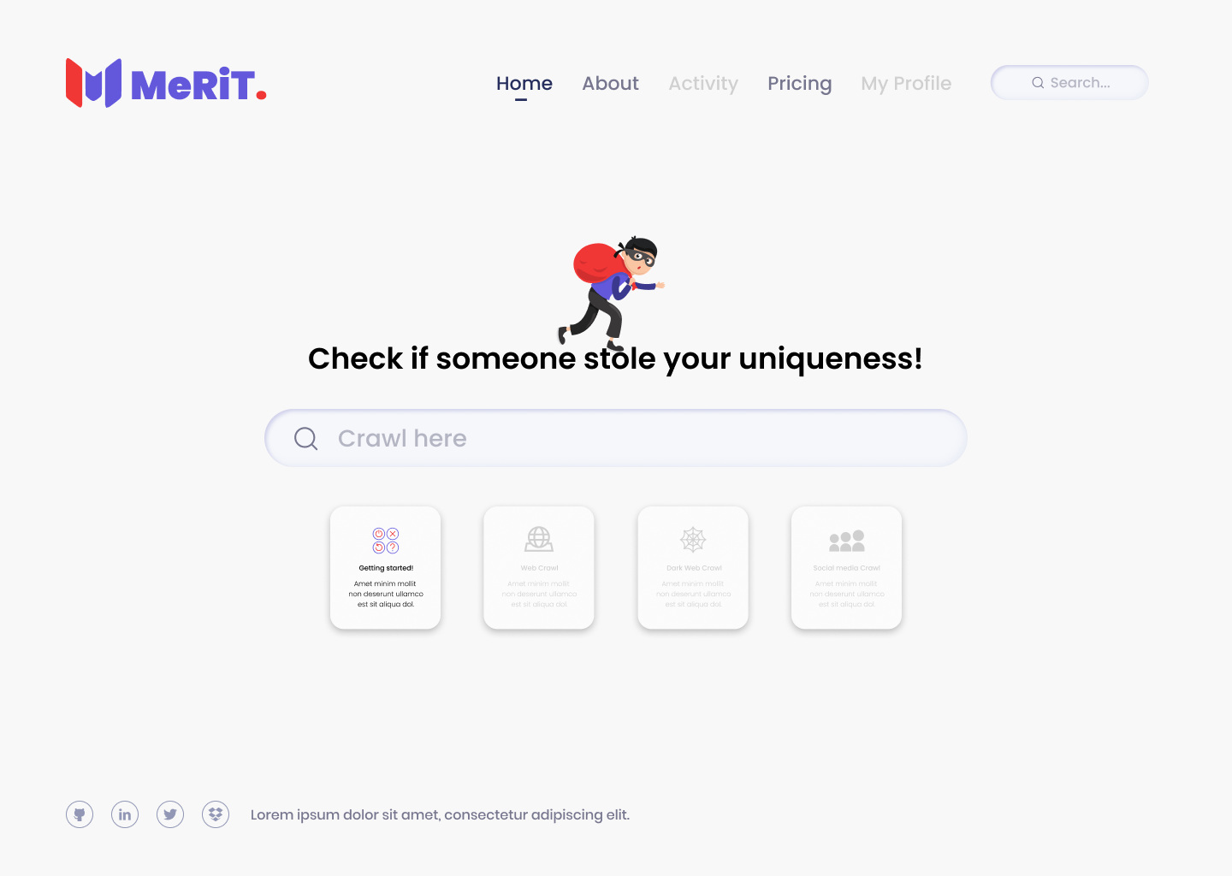

5. Signup Page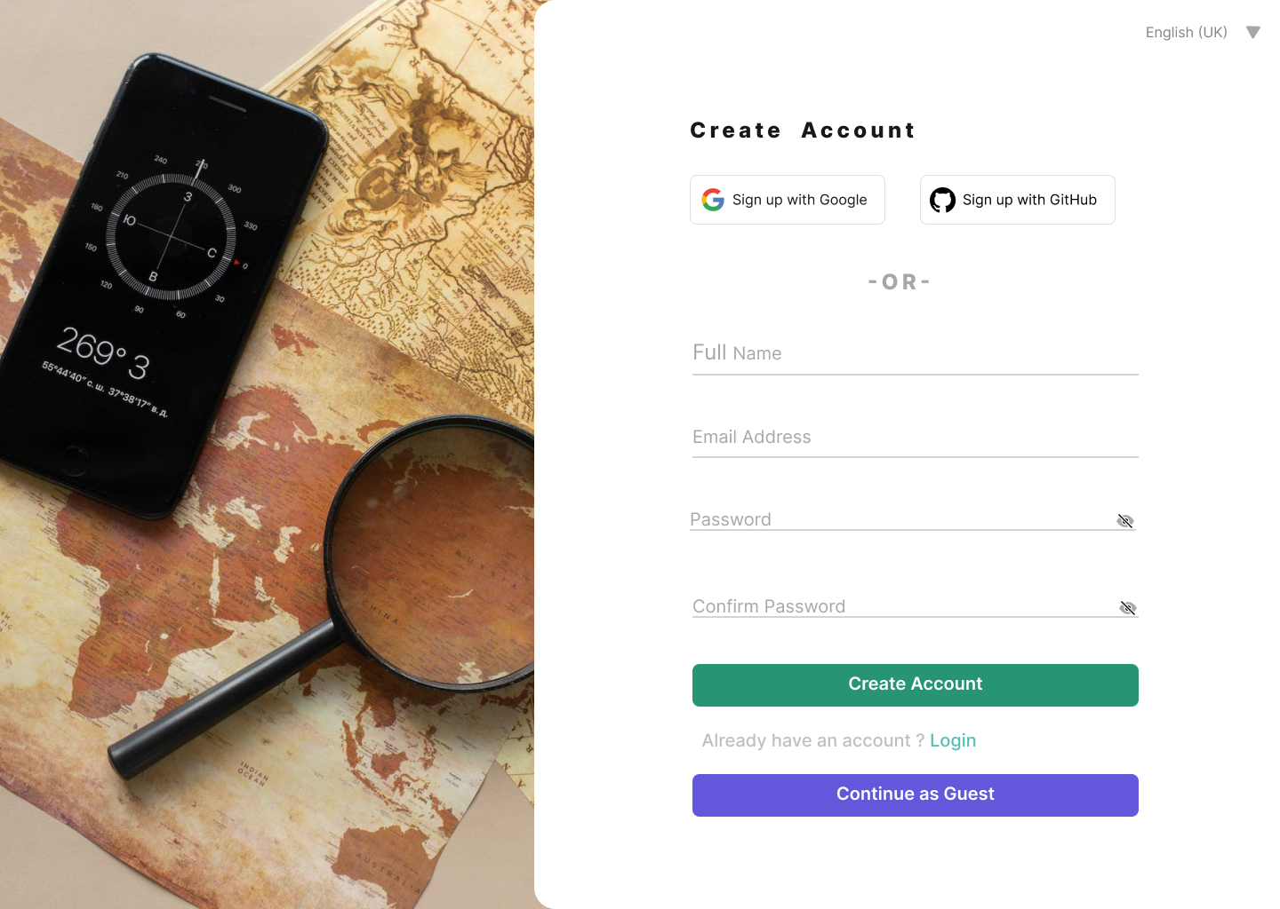

6.Login Page

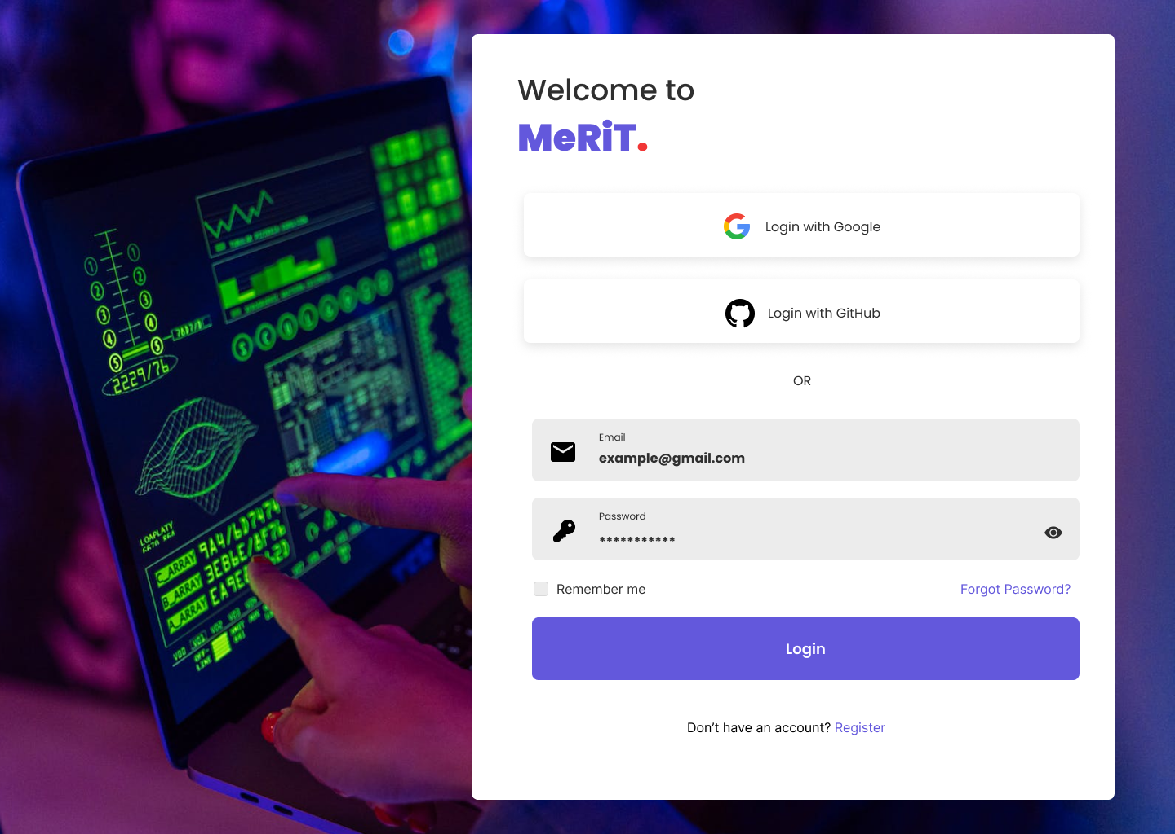

7.Premium subscription plans page

